Primary Care Provider Campaign

Resources
- Landing page: https://nebraskahealthnetwork.com/primarycare
- Social Media Kit: https://nebraskahealthnetwork.com/primarycaresocial
- Patient Resource: Benefits of a PCP
- Patient Resource: Appointment Prep Form

Key Messages
- Starting Your PCP Search
- Know Before You Go, Make the Most of Your Appointment
- Benefits of Partnering with a Primary Care Provider

Main Hashtag:
#PrimaryCareWorksForYou

Key Message 1: Starting Your PCP Search

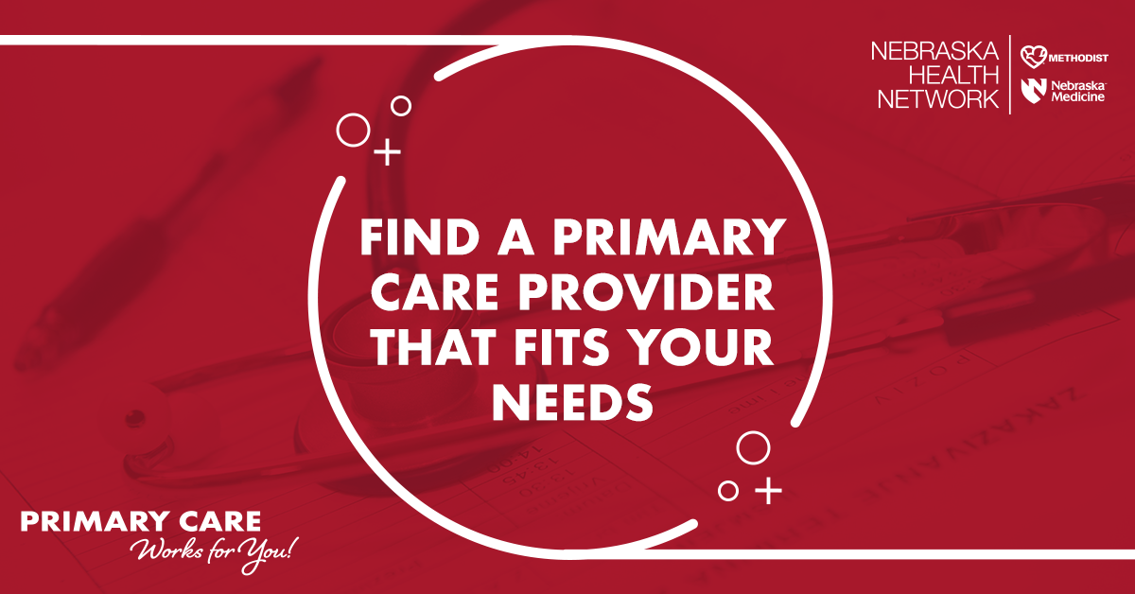1. Image: Find a Primary Care Provider that Fits Your Needs
Caption: Our clinic has primary care providers that are ready to get you started on your health-care journey. Visit https://nebraskahealthnetwork.com/primarycare/ to learn more about the benefits of partnering with a primary care provider. #PrimaryCareWorksForYou
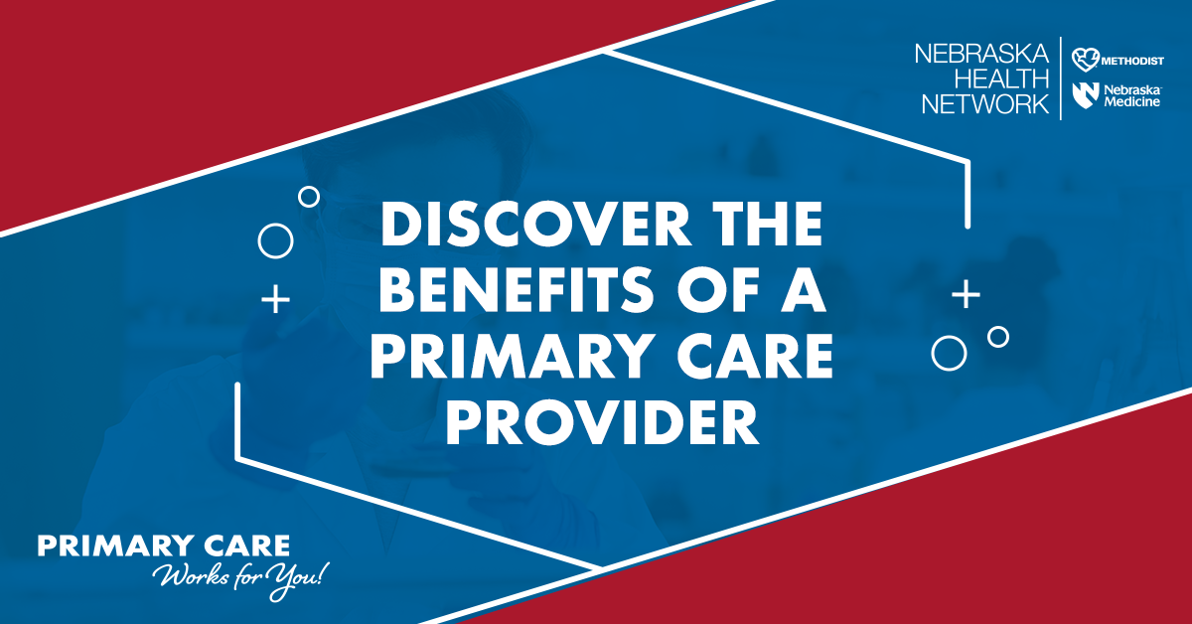2. Image: Discover the benefits of a primary care provider
Caption: Interested in visiting with a primary care provider but not sure where to start? Nebraska Health Network has created resources to guide you through choosing a primary care provider. Visit https://nebraskahealthnetwork.com/primarycare/ to download resources today. #YourPrimaryCare #PrimaryCareWorksForYou

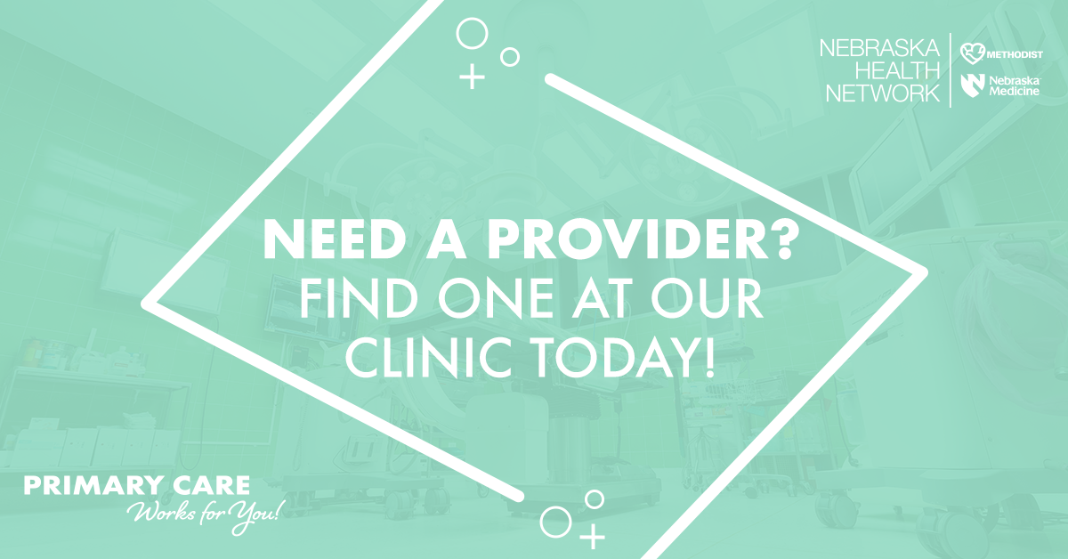
3. Image: Need a Provider? Find one at our Clinic!
Caption: Our clinic includes more than (# of providers at clinic) primary care providers to choose from. Confidently pick a provider by reviewing the benefits with resources from the Nebraska Health Network. https://nebraskahealthnetwork.com/primarycare/ #PrimaryCareWorksForYou

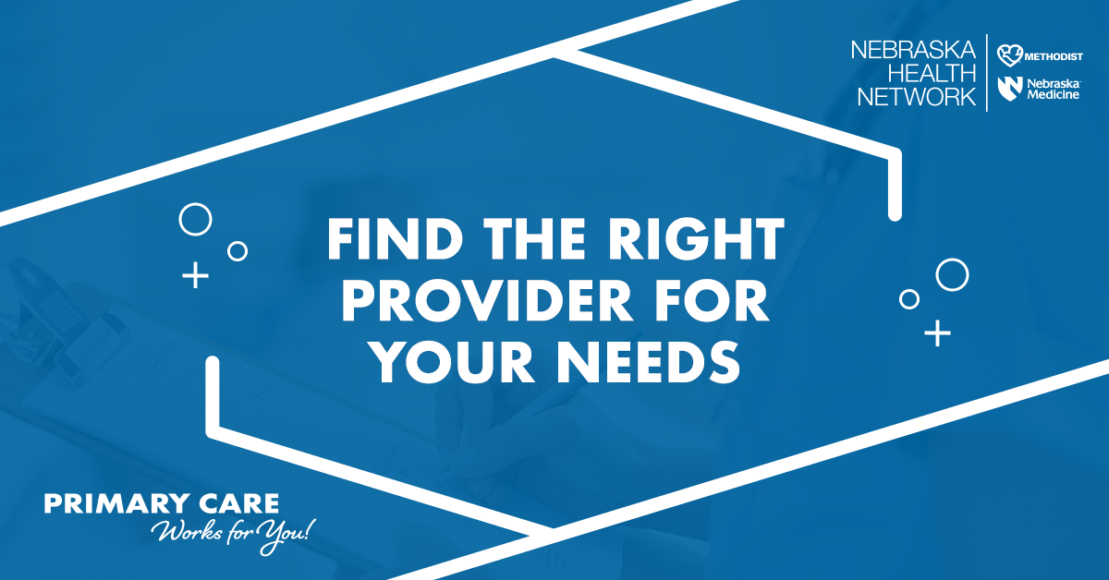4. Find the Right Provider for you Needs
Caption: Finding the perfect primary care provider shouldn’t be stressful. With (# of providers) at our clinic, we can help you find the right provider for your needs. Visit https://nebraskahealthnetwork.com/primarycare/ to learn how to prepare for your appointment. #PrimaryCareWorksForYou

Key Message 2: Know Before You Go, Make the Most of Your Primary Care

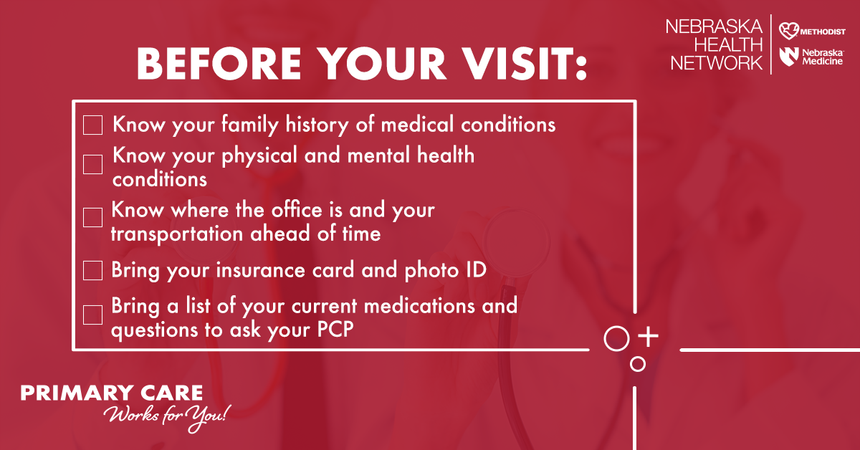

- Image: Before Your Visit checklist
Caption: Not sure what to expect during a primary care appointment? Learn more about how to prepare, what to expect during the appointment and how to make the most out of the time with your care team. Download the Nebraska Health Network’s overview and Appointment Planning Guide at https://nebraskahealthnetwork.com/primarycare/ today. #KnowBeforeYouGo #PrimaryCareWorksForYou
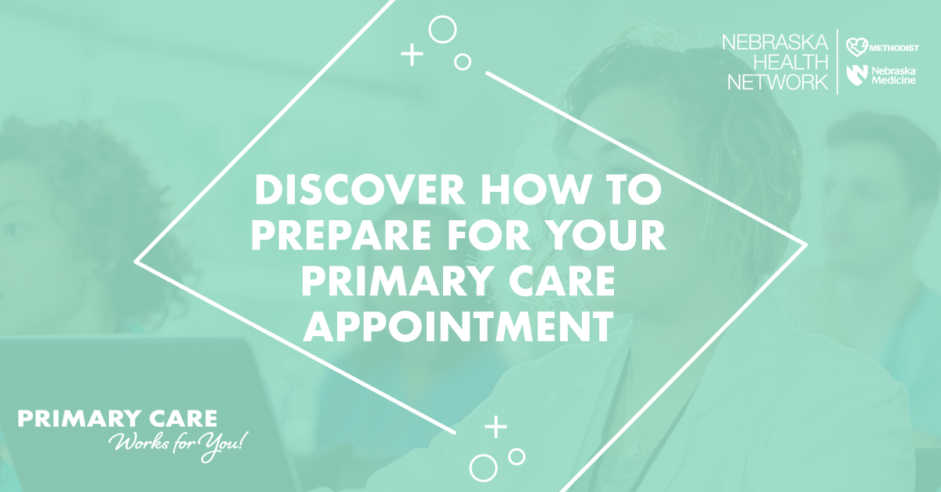2. Image: Discover how to prepare for your Primary Care appointment
Caption: Make the most out of your primary care appointment by preparing in advance. To discover what to bring and what questions to ask, visit https://nebraskahealthnetwork.com/primarycare/. You can even download a copy of the Appointment Planning Guide to answer common questions your provider may ask you beforehand. #KnowBeforeYouGo #PrimaryCareWorksForYou

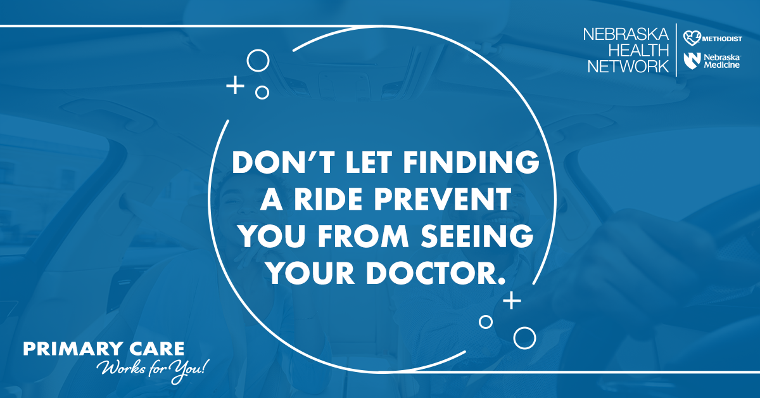3. Image: Don’t let finding a ride prevent you from seeing your doctor.
Caption: Sometimes, going to the doctor isn’t as easy as it should be. If reliable transportation is preventing you from seeing your primary care provider, know that there are resources available. Visit https://communityrelay.com/ and search “transit” to find support services. Don’t let a ride prevent you from prioritizing your health. https://nebraskahealthnetwork.com/primarycare/ #KnowBeforeYouGo #PrimaryCareWorksForYou

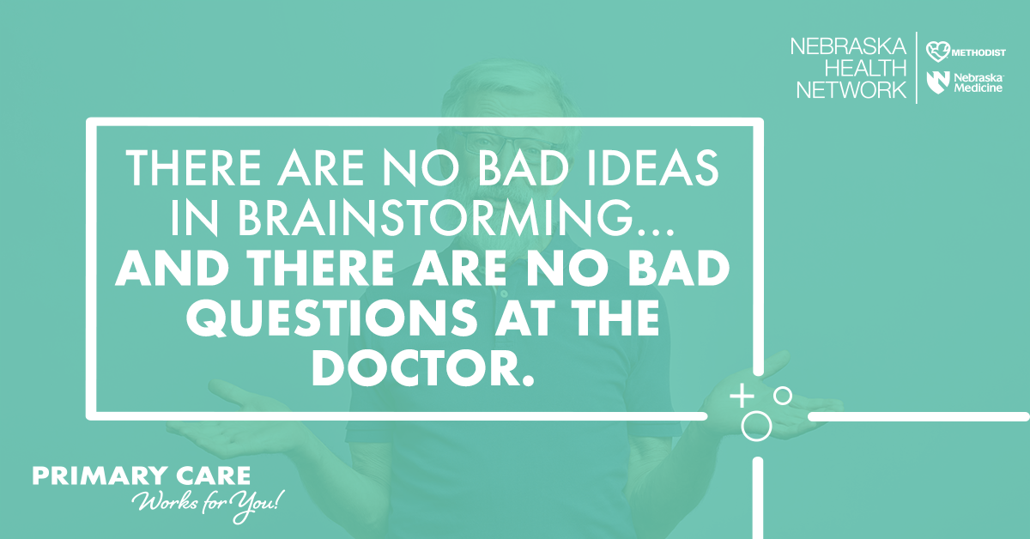4. Image: There are no bad ideas in brainstorming... and there are no bad questions at the doctor.
Caption: Your primary care provider is a trusted resource that is here to help. Take time to share your concerns, answer questions honestly and don’t be afraid to ask for help. Learn more about what to expect at your appointment, how to prepare and how primary care can help you! #PrimaryCareWorksForYou #YourPrimaryCare https://nebraskahealthnetwork.com/primarycare/

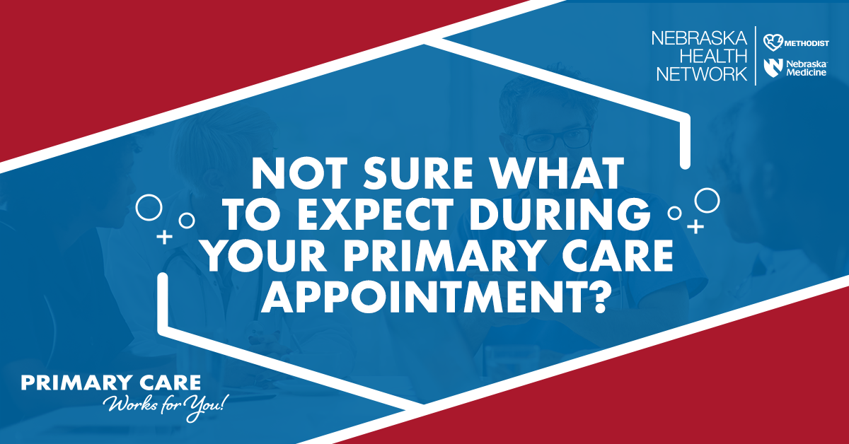5. Image: Not sure what to expect during your Primary Care appointment?
Caption: Don’t let fear hold you back. Your primary care provider is a trusted resource focused on you! Contact our clinic at (insert clinic contact) to learn more about the benefits of working with a primary care provider, what to expect during the appointment and how to prepare. You can also download primary care resources at https://nebraskahealthnetwork.com/primarycare/. #YourPrimaryCare #PrimaryCareWorksForYou

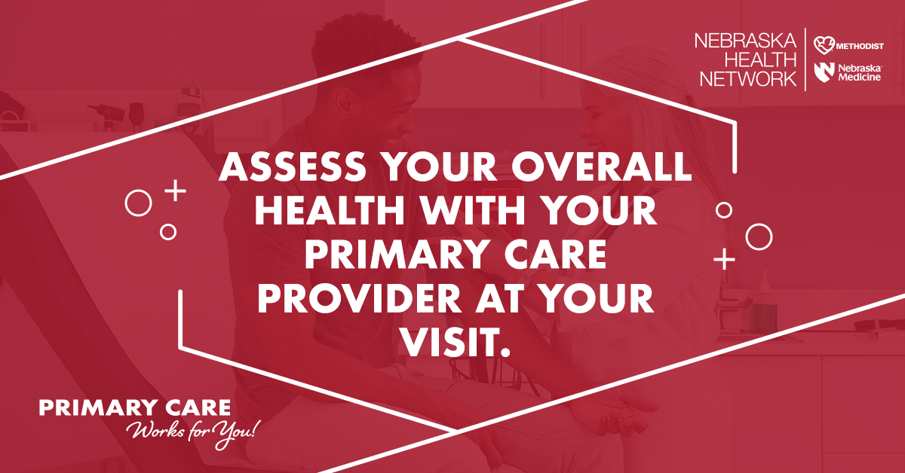6. Image: Assess your overall health with your primary care provider at your visit.
Caption: You’ve scheduled your appointment, but what’s next? A visit with your primary care provider is an opportunity to assess your overall health. Your care team will monitor things like your vitals, height, weight and blood pressure. Most importantly, they want to hear from you. Take this time to ask the important questions, share your concerns and be open about your health goals. Learn more and download resources at: https://nebraskahealthnetwork.com/primarycare/. #YourPrimaryCare #PrimaryCareWorksForYou

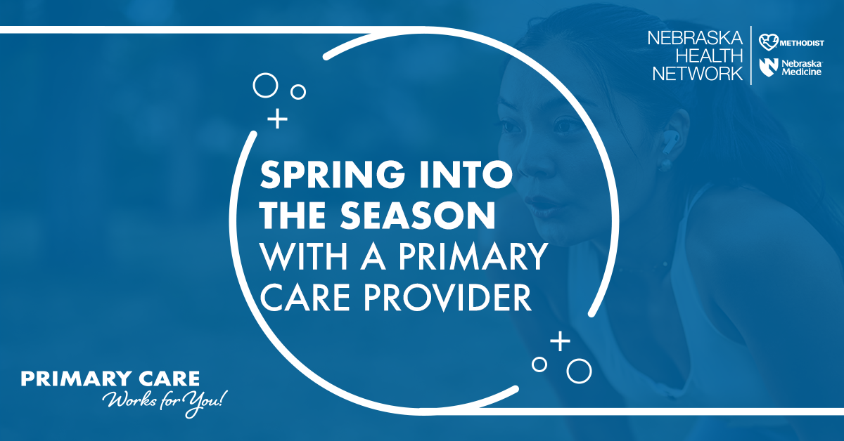7. Image: Spring into the Season with a Primary Care Provider.
Caption: Putting off your health goals? As Spring approaches, it is the perfect time to schedule an appointment with your primary care provider. In addition to treating chronic and minor illnesses, primary care providers are focused on keeping you healthy! Schedule time today to discuss your health background and develop goals that are meaningful to you! https://nebraskahealthnetwork.com/primarycare/ #PrimaryCareIsPreventiveCare #PrimaryCareWorksForYou

Key Message 3: Benefits of Partnering with a Primary Care Provider

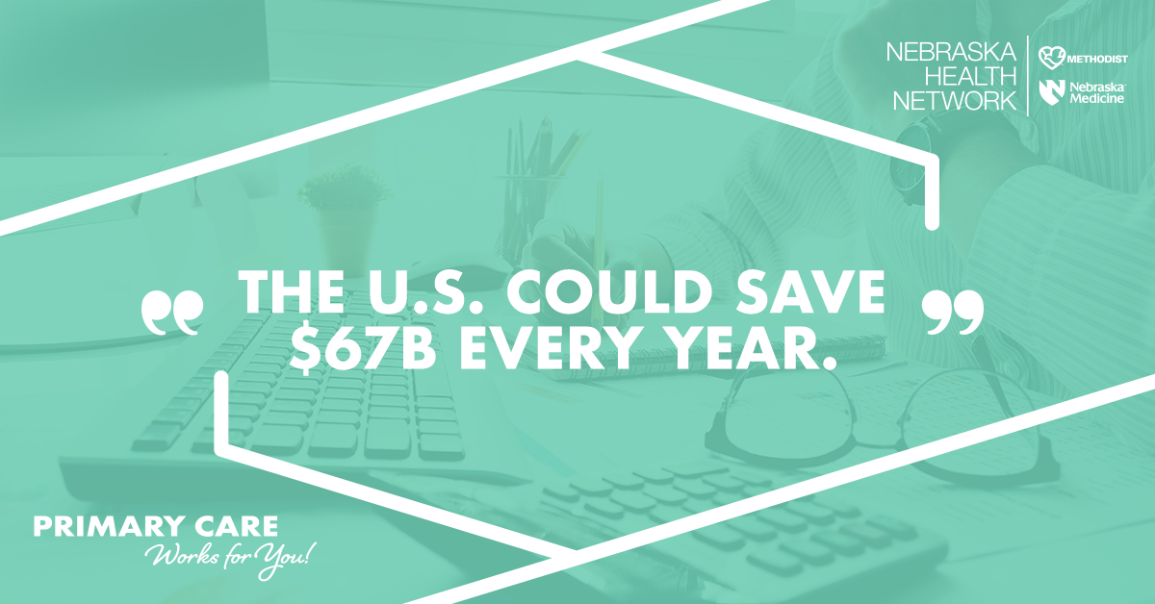

- Image: The U.S. could save $67B every year.
Caption: If every person saw a primary care provider, the US would save an estimated $67 billion every year. Primary care providers help get and keep you healthy. Early detection helps treat illnesses before they progress and partnering with a primary care provider can lower ER visits, hospitalizations and more. Read about the benefits at https://nebraskahealthnetwork.com/primarycare/. #PrimaryCareWorksForYou #PrimaryCareIsPreventiveCare

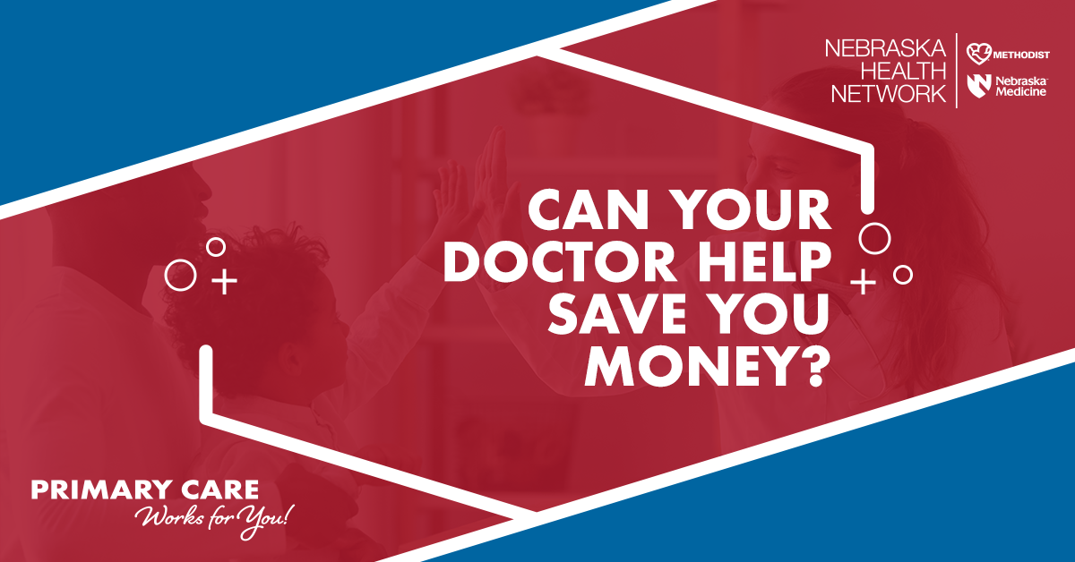
2. Image: Can your doctor help save you money? Caption: Can seeing your doctor help you save money? Yes. Health-care costs tend to be lower for people who have a primary care provider monitoring their health and coordinating their care. Find out more about what to expect during a primary care provider visit, how to prepare and find the provider best for you! Visit https://nebraskahealthnetwork.com/primarycare/. #PrimaryCareWorksForYou #YourPrimaryCare

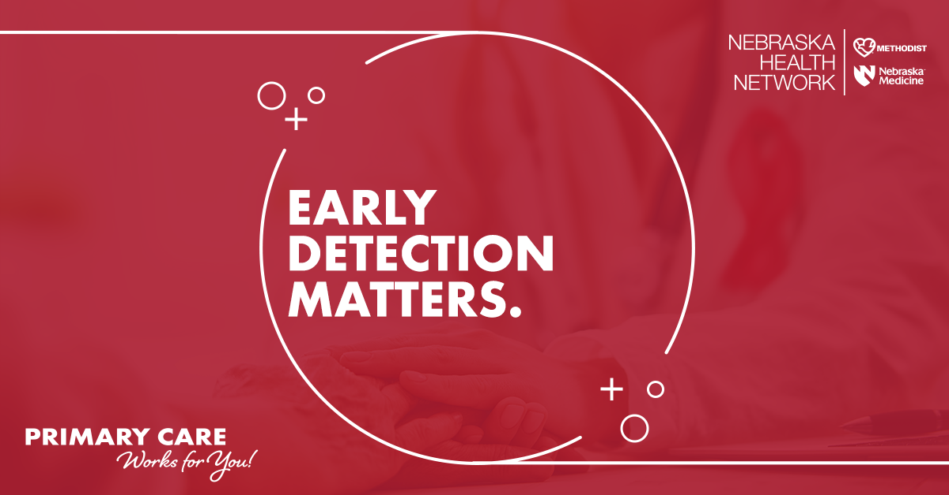
3.Image: Early detection matters.
Caption: Having a primary care provider can help you live longer by decreasing your risk of dying from heart disease, cancer or stroke. Primary care providers are here to help. They can treat and detect minor illnesses and problems before they turn serious. Learn more about the benefits of primary care and how to prepare for an appointment at https://nebraskahealthnetwork.com/primarycare/. #YourPrimaryCare #PrimaryCareWorksForYou

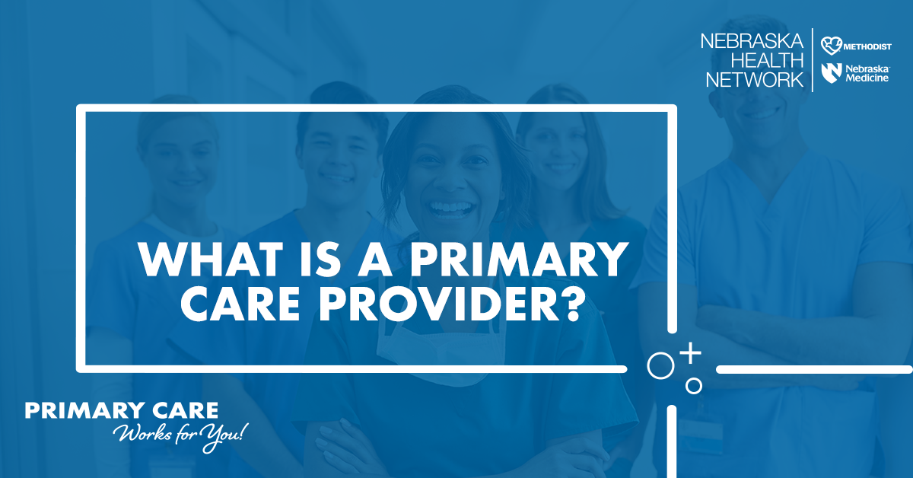
4. Image: What is a Primary Care Provider?
Caption: Primary care providers can be physicians or advanced practice providers like nurse practitioners or physician assistants. Regardless of their title, primary care providers are champions for your health. They are focused on getting and keeping you healthy. Learn more about the benefits of partnering with a primary care provider at https://nebraskahealthnetwork.com/primarycare/. #YourPrimaryCare #PrimaryCareWorksForYou

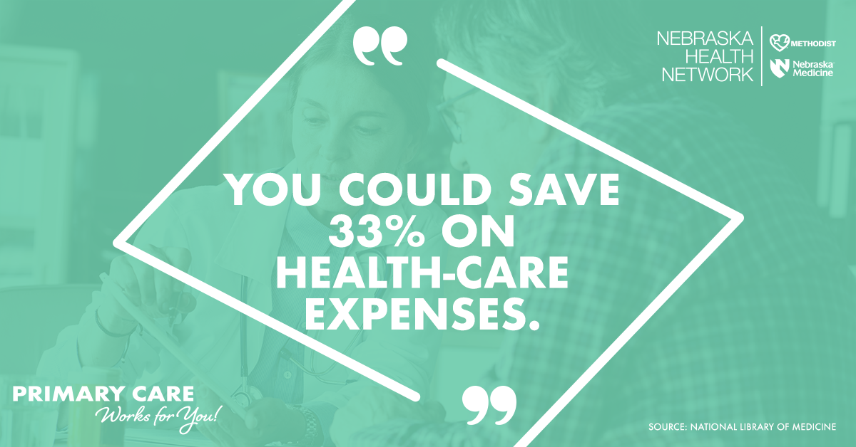5. Image: You could save 33% on health-care expenses.
Caption: A primary care provider will save you money in the long run. Just by having a primary care provider, you can save 33% on health-care costs compared to those who only see specialists for their care. They will help keep track of your health throughout the course of your life and help coordinate your overall care. Staying healthy will be less complicated when you partner with a primary care provider. Find out how you can benefit at https://nebraskahealthnetwork.com/primarycare/. #YourPrimaryCare #PrimaryCareWorksForYou

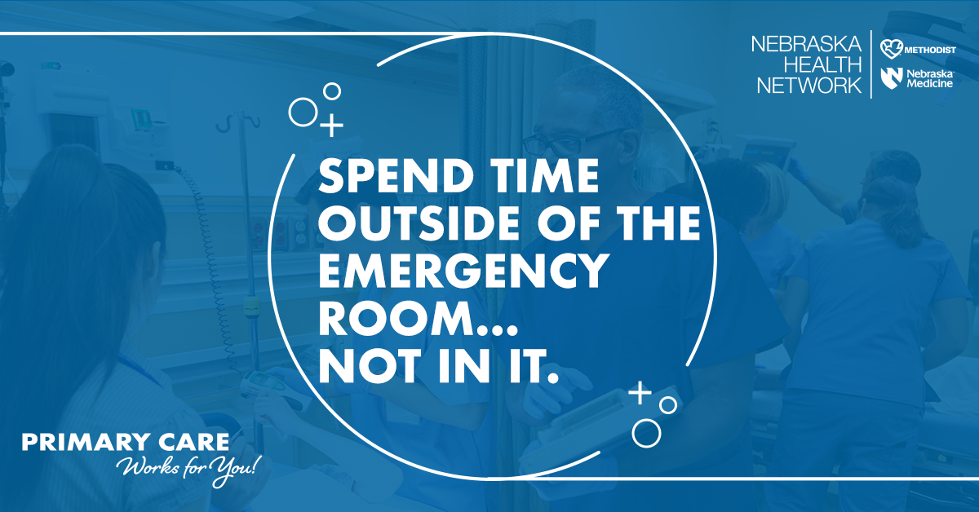6. Image: Spend time outside of the emergency room...Not in it.
Caption: Your primary care provider is here to help. They can provide care that will help you avoid unnecessary trips to the emergency room. Emergency room care can cost as much as four times that of other outpatient care. Avoid spending time and money on more care this year and learn about the benefits of having a primary care provider at https://nebraskahealthnetwork.com/primarycare/. #YourPrimaryCare #PrimaryCareWorksForYou

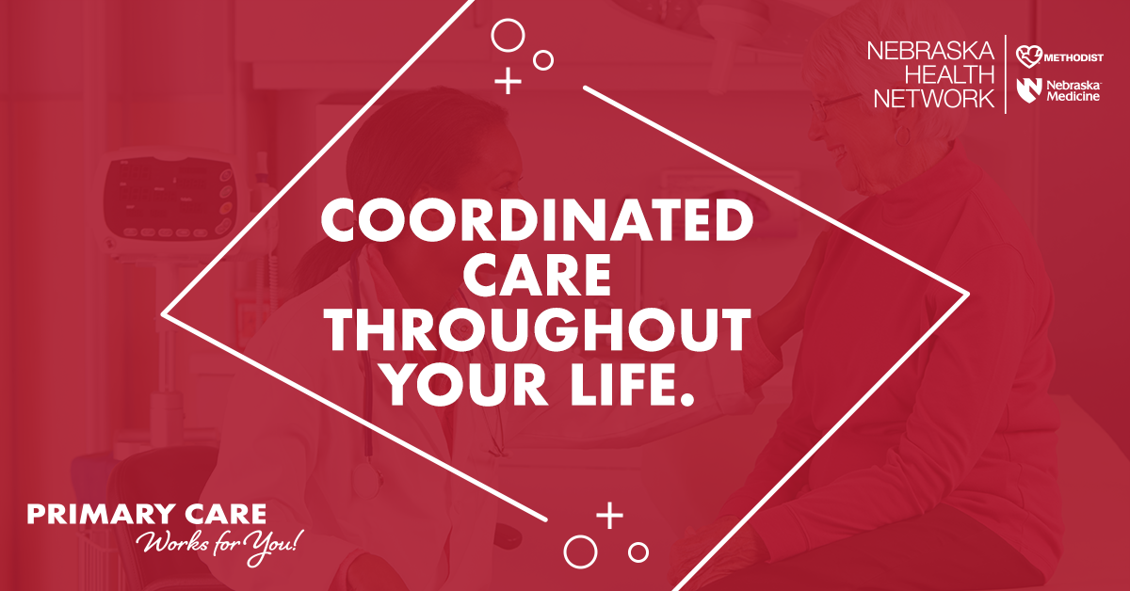7. Image: Coordinated care throughout your life.
Caption: Different types of care specialists can be confusing. But what if you could have someone helping you coordinate care for the entirety of your life? That’s what a primary care provider can do for you. They’ll refer you to the right specialist if necessary and may lower your odds of premature death by 19%, compared to those who only see specialists. Find more information at https://nebraskahealthnetwork.com/primarycare/. #PrimaryCareWorksForYou #YourPrimaryCare

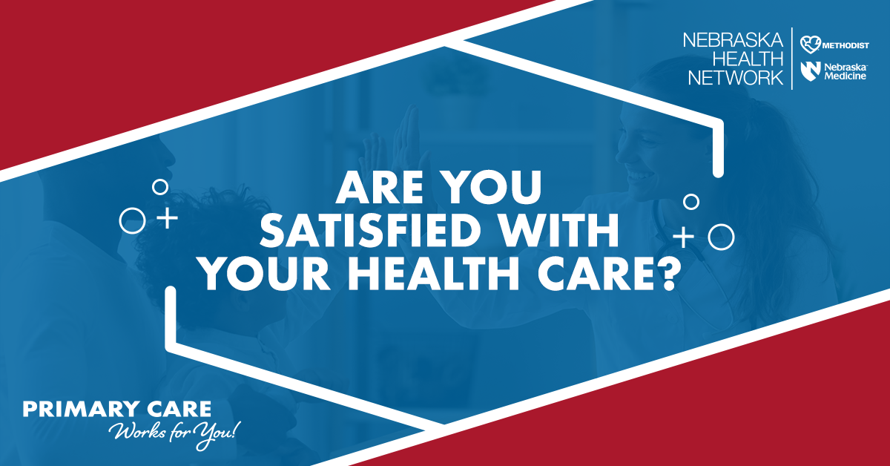8. Image: Are you satisfied with your health care?
Caption: Patients with a primary care provider reported a 10% increase in patient satisfaction with health care. Your health-care journey can be less stressful and you will have someone helping you through. Let us help you find the right provider at our clinic today. Contact us at (clinic contact info) to get started.
#YourPrimaryCare #PrimaryCareWorksForYou

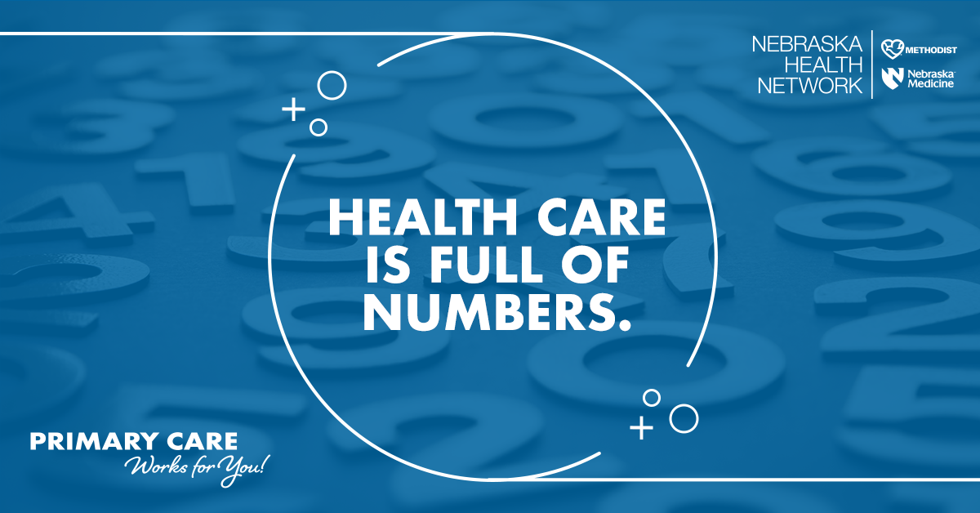
9. Image: Health care is full of numbers.
Caption: Health care is full of numbers. What do they all mean for you? Your primary care provider can help keep track of important tests and outcomes so you can avoid duplicate screenings and exams. Take the confusion out of health care by partnering with a primary care provider. Find more information at https://nebraskahealthnetwork.com/primarycare/. #YourPrimaryCare #PrimaryCareWorksForYou
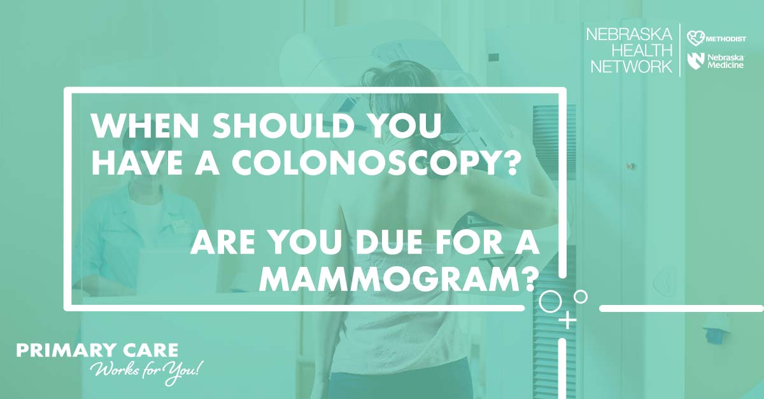10. Image: When should you have a colonoscopy? Are you due for a mammogram? Caption: You may or may not know what preventive screenings are best for you, but your primary care provider does. Your care provider will help you when you are sick AND focus on preventive care and wellness to optimize your health. Contact our clinic at (contact info) today to find out how and download PCP resources from the Nebraska Health Network
at https://nebraskahealthnetwork.com/primarycare/. #YourPrimaryCare #PrimaryCareWorksForYou

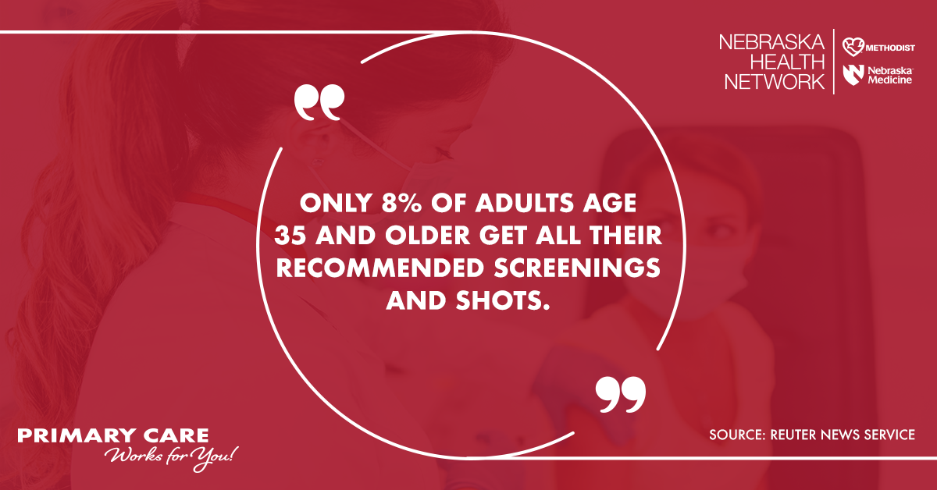11. Image: Only 8% of adults age 35 and older get all their recommended screenings and shots.
Caption: Reuters News Service reports that “only 8% of adults age 35 and older get all their recommended screenings and shots.” Your primary care provider knows which screenings and shots you have and haven’t gotten so you don’t have to keep track of it all. They will work with you to make sure you are up-to-date on all the necessary tests. Don’t delay your health any longer, let us help you find a provider at (clinic contact info). #PrimaryCareIsPreventiveCare #PrimaryCareWorksForYou

